Breakthrough Easy Read Application Form
 | About this programme
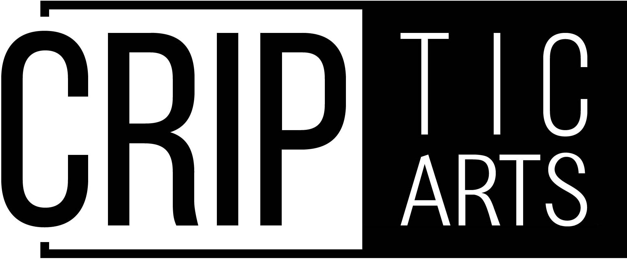 | Breakthrough is a programme run by an organisation called CRIPtic Arts.
 | CRIPtic Arts is run by disabled people. This is Jamie Hale. Jamie runs CRIPtic Arts.
 | Breakthrough is for deaf and disabled artists.
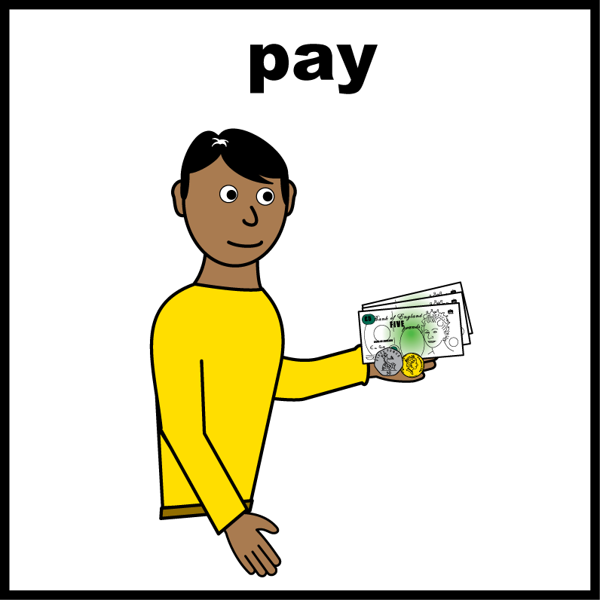 | We give artists money to make something small.  It should be as good as possible
 | Do you want to be one of them?
 | How to apply
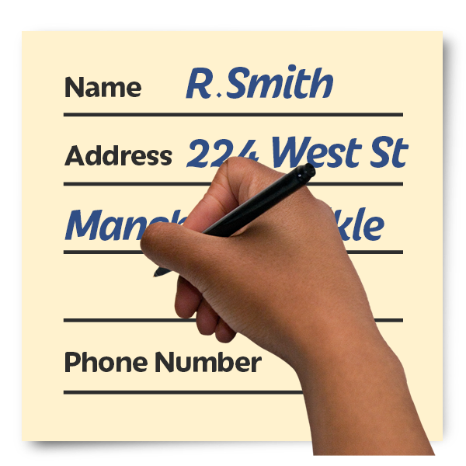 | Fill in this form
 | Send it to artists@cripticarts.org by 5pm on Friday 13 March 2026.
 | Questions
 | Your name
 | Write your answer here
 | Your pronouns
 | Write your answer here
 | Are you disabled?  Breakthrough is only for disabled people
 | Write your answer here
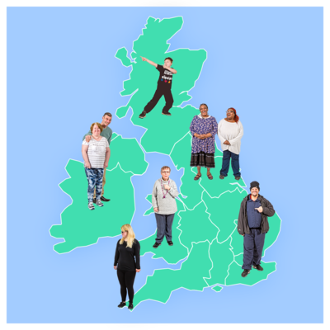 | Where in the UK are you based?
 | Write your answer here
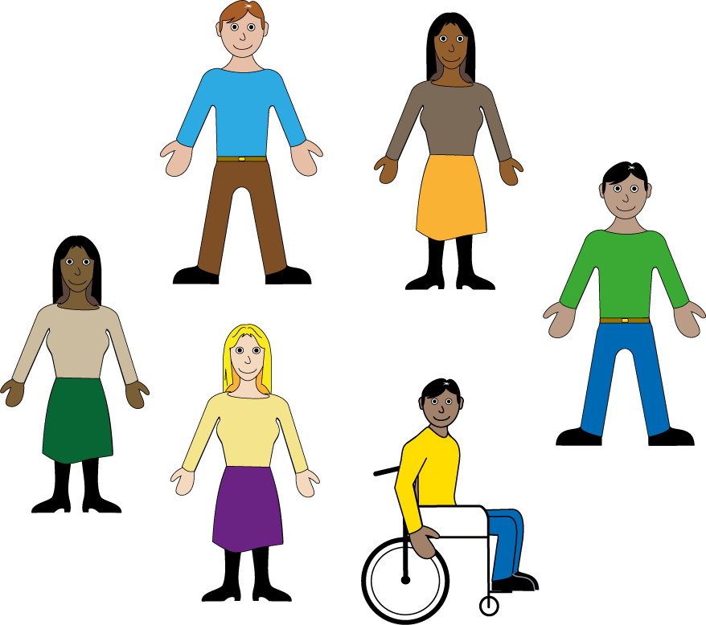 | We want to work with more people from lots of different groups  Are you a person from the Global Majority?  Are you working class?  Are you a carer for someone else?
Write your answer here

Yes / No
 | Tell us about your creative work
 | What you enjoy making
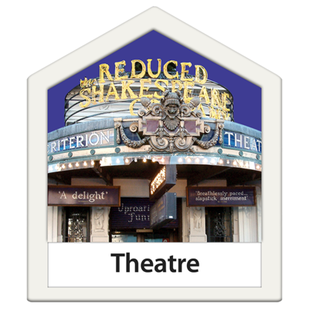 | Training or performances you have done
 | Write your answer here
 | Tell us about your Breakthrough idea:  - What do you want to do?
 | Write your answer here
 | How would Breakthrough help your career?
 | Write your answer here
 | What is difficult for you  How Breakthrough would make that easier  - What barriers you face because you are a disabled person  - How these barriers make it hard for you to reach your goals  - How the Breakthrough Award would help you
 | Write your answer here
 | How can we help you?  Tell us:  Why you want to work with CRIPtic  How we can help you reach your goals
 | Write your answer here
 | Show 3 examples of your work (video/images/writing)
Write your answer here
1.

2.

3.
 | Optional Questions  Only answer these questions if you want to
 | Some disabled people have problems working in the arts
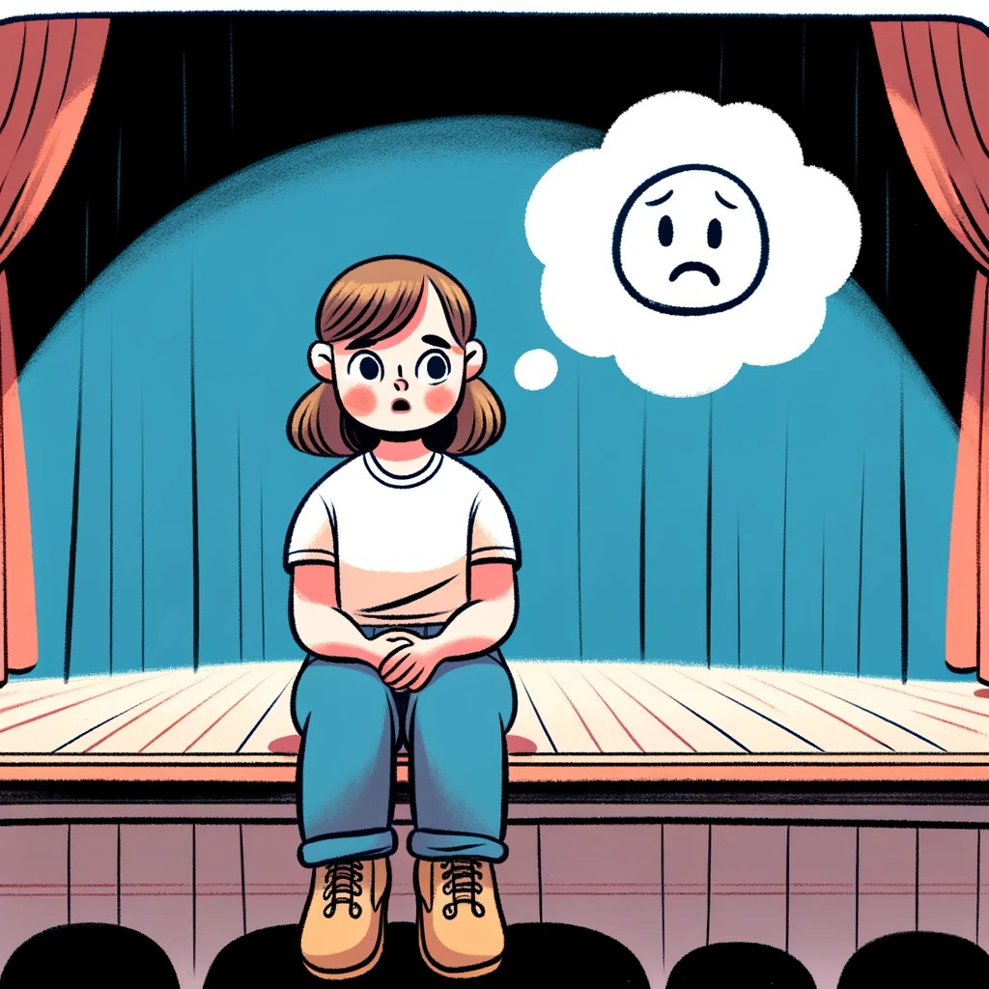 | What problems have you had in the arts?
 | Write your answer here
 | Will you need any of:
 | BSL interpreter?
 | Wheelchair access?
 | Support worker?
 | Write your answer here
 | Do you need any other help?
 | Write your answer here
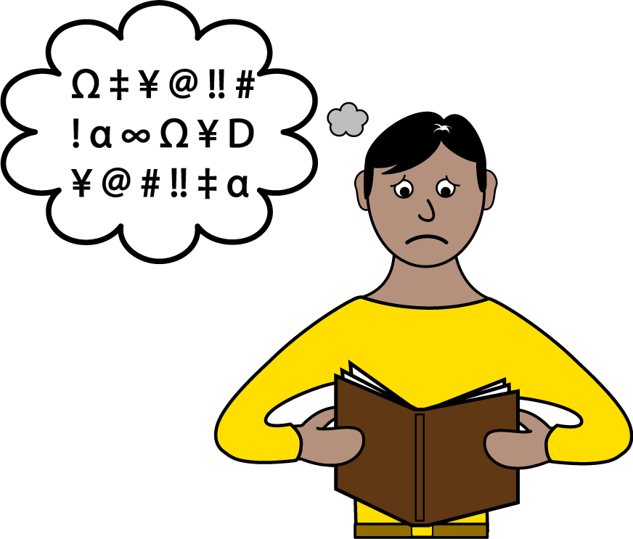 | Was this form difficult for you?  Which parts were difficult for you?
 | Write your answer here
 | Can we store what you have told us?  We need to do this to consider your application.  We will store it safely.
 | Yes / No
 | Can we email you about this and other things we think you might be interested in?
 | Yes / No
 | Thank you for applying!  We will send you an email in March.

